EXPERIMENT 2
GENERATION OF SQUARE WAVE USING PROTEUS
AIM: To write an assembly language program to generate square wave using AT89C51.
SOFTWARE REQUIRED: Proteus 8 software
ALGORITHM
- Initialize program execution.
- Set P2.0 HIGH and wait for the delay.
- Clear P2.0 and wait for the same delay.
- Repeat the sequence continuously to obtain a square wave.
PROGRAM
ORG 0000H
UP: SETB P2.0
ACALL DELAY
CLR P2.0
ACALL DELAY
SJMP UP
DELAY: MOV R4,#35
H1: MOV R3,#255
H2: DJNZ R3,H2
DJNZ R4,H1
RET
END
OUTPUT IMAGE

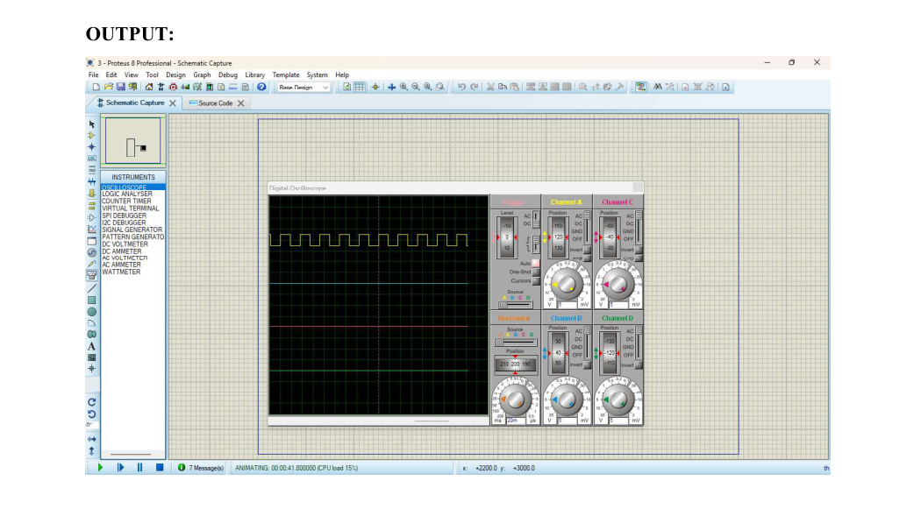

RESULT
Thus the program has been successfully verified and executed.

